Name ________________________ HOMEWORK Dec. 12-16
Module 4 Week 4
Put your initials by each night that your child practiced the following:
____ Monday ____Tuesday ____Thursday
*Nightly Homework*
1. Count numbers 1-50.
2. Practice assigned Sight Word list in red reading folder.

MONDAY-Blend onset and rime into words.
Look at the picture. | Blend the onset and rime. | Write the word.
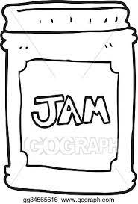 | am  j
ush
br
in
w

Trace and practice forming the letters.
Ww Ww Ww ______

Jj Jj Jj ______
TUESDAY-
Read it. Trace it. Write it.
had had ____ be be ____
do do ____ ten ten ____
Circle the words that begins with the /j/ sound with a blue crayon and the words that begin with the /w/ sound with a green crayon.
jam wag jot web jig

win jog wish jug wind

THURSDAY-
Name each picture. Write the first letter for each word.
________ | ________ | 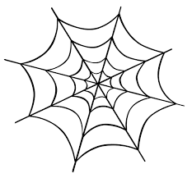________
________ | 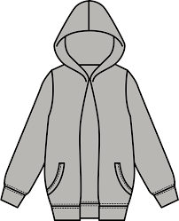________ | ________

Read the word circle the picture.
well  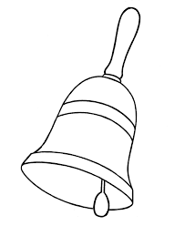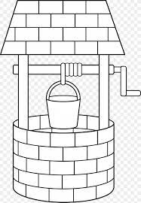 | web  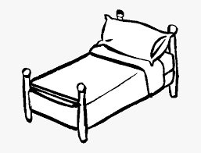 | jam

Start Right Reader Module 4 Week 4
Words to Know
do
ten

Jobs! Jobs! Jobs!
He digs big, big pits. It is a big, big, job! He ran ten laps. He can do it! Win! Win! Win! If it rips, she can pin it. She can pin it. It fits! She jogs with ten dogs. Ten dogs wag! Wag! Wag! Wag! It sits on a tin pan. He tops it with jam. He dips it in. He dabs dots on it. Dots! Dots! Dots!

